**The Health App Group: Project 3**

**Date: 07/30/2022**

**Question 1 : System Analysis Script**

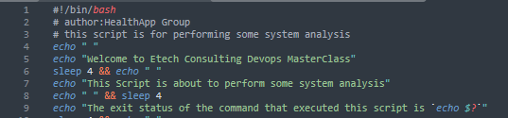

Line 6 adds an interval and adds a blank line while the script is running

Line 9 prints the exit status of the last ran command which is the command to run the script

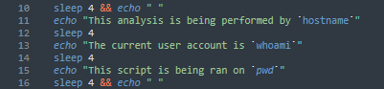

Line 11 tells who is running the script

Line 13 displays the current user

Line 15 tells the location where the script was ran

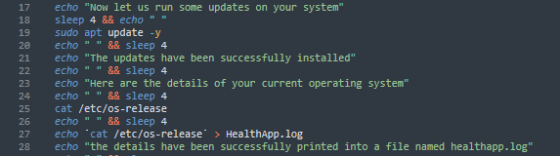

Line 19 runs updates on the system

Line 25 displays the version of the operating system

Line 27 prints the details of the OS version into a file named HealthApp.log

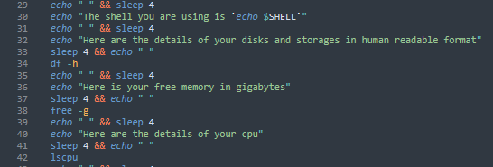

Line 30 tells you which shell you are using

Line 34 displays your available space and other details about your storage spaces

Line 38 displays your free memory in gigabytes

Line 42 displays the details of the CPU

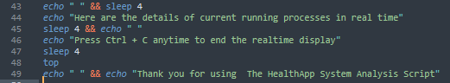

Line 48 displays the running processes in the system. It will keep running till you follow the instruction on line 46

**Question 2: The Bank Account Script**

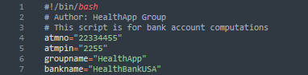

Line 4 to 7 defined some of the variables used in the script

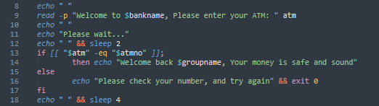

Line 9 prompts you to enter your atm, the number 22334455 as defined in the variable will substitute for entering your atm card

Line 13 checks if the number you have entered matches the number defined in the hardcoded variable.

Line 14 welcomes you if you enter the correct atm number

Line 16 ends the script if you enter the wrong atm number

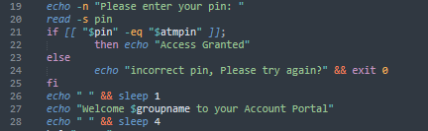

Line 19 requests for your pin 2255 as defined in the pin variable

Line 20 reads the pin in hidden mode

Line 21 checks if the pin you have entered matches the pin that has been defined in the hard-coded variable

Line 24 ends the script if the incorrect pin is entered

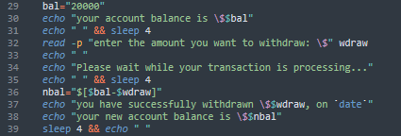

Line 29 defines the beginning balance variable

Line 32 prompts you to enter the amount you wish to withdraw

Line 36 defines the variable for the new balance after withdrawal

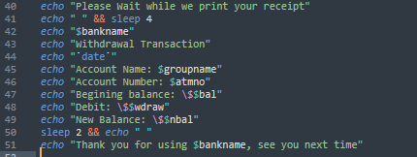

This part prints your receipt while attaching the already defined variables

Question 4

Question 4: write a shell script to backup and archive all logs from /var/log/auth.log such that your backup file name should be yourgroup.date.log. your script should equally transfer the tar file into the remote server with below details: ip address:

username: team3 key: team3key.pem directory: /tmp/monitor

the key 'team3key.pem' will be dropped on your class channel

list all logs from the file: $ls /var/log/*auth.log

